Prepositions of Direction/Movement

🔹 What Are Prepositions of Direction / Movement?
# Source: AI Source: Provided by: [Data Path: Persons Table -> ID Column: 1, Name_En Column: Motasem Essam] -> From: [Chatgpt (GPT-4-turbo)] on [7/28/2025]
Prepositions of direction or movement describe motion from one place to another.
They answer the question: Where to? or Which way?
These prepositions are often used with verbs of motion like go, move, run, walk, throw, etc.

✅ Common Prepositions of Direction / Movement
# Source: AI Source: Provided by: [Data Path: Persons Table -> ID Column: 1, Name_En Column: Motasem Essam] -> From: [Chatgpt (GPT-4-turbo)] on [7/28/2025]
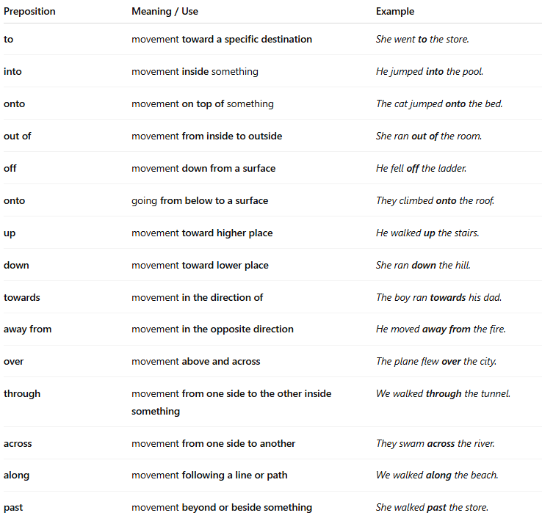
Preposition | Meaning / Use | Example
to | movement toward a specific destination | She went to the store.
into | movement inside something | He jumped into the pool.
onto | movement on top of something | The cat jumped onto the bed.
out of | movement from inside to outside | She ran out of the room.
off | movement down from a surface | He fell off the ladder.
onto | going from below to a surface | They climbed onto the roof.
up | movement toward higher place | He walked up the stairs.
down | movement toward lower place | She ran down the hill.
towards | movement in the direction of | The boy ran towards his dad.
away from | movement in the opposite direction | He moved away from the fire.
over | movement above and across | The plane flew over the city.
through | movement from one side to the other inside something | We walked through the tunnel.
across | movement from one side to another | They swam across the river.
along | movement following a line or path | We walked along the beach.
past | movement beyond or beside something | She walked past the store.

📚 Example Sentences
# Source: AI Source: Provided by: [Data Path: Persons Table -> ID Column: 1, Name_En Column: Motasem Essam] -> From: [Chatgpt (GPT-4-turbo)] on [7/28/2025]
- The dog ran into the house.
- They jumped onto the platform.
- He walked along the river.
- We moved away from the danger.
- She looked through the window.

